Student Name: Ben Sottile

Class and Section CS-210-02

Total Points (40 pts + 2 extra pts) __________________

**Due: Refer to Blackboard (Late homework submission is not acceptable! You must turn in your own work in blackboard!)**

#### **Project: Project: Math Learning Tool**

CS210 Introduction to Programming Principles

California Lutheran University

Problem Description:

Write a program that prompts the user to select one of these Math practices categories (Simple, Medium, Hard). Then promote the user to select one of these arithmetic operation (+, -, /, *, %) that they want to practice. For Simple selection generate two random integer numbers between 0 to +10, for Medium selection generate two double precision numbers between 0.00 to 100.00 and for Hard selection generate two double precision numbers between 0.00 to 1000.00. Show the problem statement to the user and ask them for the answer then check if their answer is correct or not correct and output the proper output to them.

Here are sample runs of the program (Show all different test cases for all possible selections): Make sure you follow chapter 12 for exception handling. Your code must have a switch/case statement. Number1 could be >= or <= number 2.

Sample 1:

Would you like (Simple, Medium or Hard) problem? Medium

What would like to practice today (+, -. /, *, %)? +

What is the answer to (45.03 + 5.03)? 50.06

Good job your answer is correct!

Sample 2:

Would you like (Simple, Medium or Hard) problem? Simple

What would like to practice today (+, -. /, *, %)? -

What is the answer to (2 - 5)? -3

Good job your answer is correct!

Sample 3:

Would you like (Simple, Medium or Hard) problem? Hard

What would like to practice today (+, -. /, *, %)? *

What is the answer to (589.05 * 258.05)? 28873.07

Your answer is wrong, the correct answer should be 152004.35!

Submit the following items:

1. Submit this world document with your answers before the due date.
2. Zip your project and submit it before the due data.
3. Analysis: (10 pts)

(Describe the program use cases. Write down the requirements for your code. Describe the stakeholders for your code. Describe what the SW should be able to do?)

(Describe the program use cases. Write down the requirements for your code. Describe the stakeholders for your code. Describe what the SW should be able to do?)

Overview: This Program prompts the user to select one of these Math practices categories (Simple, Medium, Hard). Then prompts the user to select one of these arithmetic operation (+, -, /, *, %) that they want to practice. For Simple selection generate two random integer numbers between 0 to +10, for Medium selection generate two double precision numbers between 0.00 to 100.00 and for Hard selection generate two double precision numbers between 0.00 to 1000.00. Show the problem statement to the user and ask them for the answer then check if their answer is correct or not correct and output the proper output to them.

Use cases:

Studentslearning how to do basic math.

As a game for people who enjoy doing math

As a torture device for foreign agents who hate math

Teachers who want to generate randomized practice for students,

* 1. Requirements:

The Software shall take the chosen difficulty level and type of math

The Software shall be written in JAVA.

The Software shall include the scanner.util package to take in input

The Software shall not have any coding errors.

The Software shall include a switch statement.

The Software Shall have three difficultly levels that will generate different types of numbers.

* For Simple selection generate two random integer numbers between 0 to +10,
* For Medium selection generate two double precision numbers between 0.00 to 100.00
* For Hard selection generate two double precision numbers between 0.00 to 1000.00.

The Software Then prompts the user to select one of these arithmetic operation (+, -, /, *, %) that they want to practice.

The Software will Show the problem statement to the user and ask them for the answer then check if their answer is correct or not correct and output the proper output to them.

The Software shall be documented well.

The Software shall be readable.

The Software shall be testable.

The Software shall not crash.

The Software shall throw back any invalid.

1. Design: (10 pts)

(Describe the major steps for solving the problem. Only a flow chart will be acceptable.)

Use Link to access Flowchart Online it is too large to export.

<https://www.lucidchart.com/documents/view/c7c9e645-49c2-4c1c-af31-20ad0e313c9f/0_0>

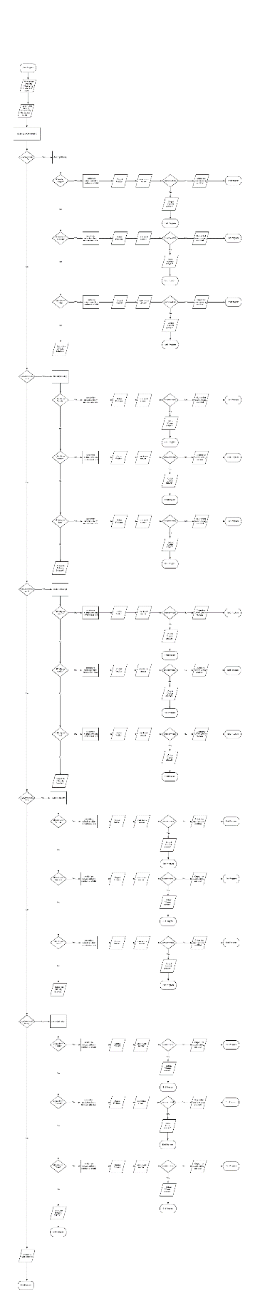

1. Coding: (10 pts)

(Copy and Paste Source Code here. Format your code using Courier 10pts. Screen shot of your code is also acceptable.)

**package** cs210;

**import** java.util.Scanner;

**public** **abstract** **class** HW5 {

**public** **static** **double** roundToHundreth(**double** pureNum) {

**int** wholeNum = (**int**)pureNum;

**double** num = (**double**)wholeNum;

**double** decimal = (**double**)(pureNum - wholeNum);

**double** decimal2 = Math.*round*((decimal * 100));

**double** roundedAnswer = num + (decimal2/100);

**return** roundedAnswer;

}

**public** **static** **void** main(String[] args) {

System.***out***.println("Welcome to Ben.co's Math Pratice Machine!");

Scanner newSc = **new** Scanner(System.***in***);

**boolean** moveOn = **false**;

String diff = **null**;

String type = **null**;

System.***out***.println("Would you like a (Simple, Medium or Hard) problem?");

**while** (moveOn == **false**) {

diff = newSc.next();

diff = diff.trim();

diff = diff.toUpperCase();

**if** (diff.equals("SIMPLE")){

moveOn = **true**;

}**else** **if**(diff.equals("MEDIUM")){

moveOn = **true**;

}**else** **if**(diff.equals("HARD")){

moveOn = **true**;

}**else** {

System.***out***.println("Please insert a valid difficulty Level:(Simple, Medium or Hard)");

}

}

moveOn = **false**;

System.***out***.println("What would like to practice today (+, -. /, *, %)?)");

**while** (moveOn == **false**) {

type = newSc.next();

type = type.trim();

type = type.toUpperCase();

**if** (type.equals("+")){

moveOn = **true**;

}**else** **if**(type.equals("-")){

moveOn = **true**;

}**else** **if**(type.equals("*")){

moveOn = **true**;

}**else** **if**(type.equals("/")){

moveOn = **true**;

}**else** **if**(type.equals("%")){

moveOn = **true**;

}**else** {

System.***out***.println("Please insert practice type:(+, -. /, *, %)");

}

}

**switch**(type) {

**case** "+":

**switch**(diff) {

**case** "SIMPLE":

moveOn = **false**;

**int** answer = 0;

**int** total;

String temp;

**int** num1 = (**int**) (Math.*random*()*10);

**int** num2 = (**int**) (Math.*random*()*10);

**while**(moveOn == **false**){

**try** {

System.***out***.println("(What is the answer to ("+ num1 +" " + type + " " + num2 + " " +")?");

answer = newSc.nextInt();

total = num1 + num2;

**if**(total == answer) {

System.***out***.println("Good job your answer is correct!");

moveOn = **true**;

}**else** {

System.***out***.println("Your answer is wrong, the correct answer should be "+total);

moveOn = **true**;

}

}**catch**(Exception e) {

temp = newSc.nextLine();

System.***out***.println("Please insert a Number!");

}

}

**break**;

**case** "MEDIUM":

moveOn = **false**;

**double** answerb = 0;

String tempb;

**int** n1 = (**int**)(Math.*random*()*10000 - 0) + 0;

**int** n2 = (**int**)(Math.*random*()*10000 - 0)+ 0;

**double** totalb = (n1 + n2)/100.00;

**while**(moveOn == **false**){

**try** {

**double** num1b = (**double**) n1/100;

**double** num2b =(**double**) n2/100;

System.***out***.println("(What is the answer to ("+ num1b +" " + type + " " + num2b + " " +")?");

answerb = newSc.nextDouble();

**if**(totalb == answerb) {

System.***out***.println("Good job your answer is correct!");

moveOn = **true**;

}**else** {

System.***out***.println("Your answer is wrong, the correct answer should be "+totalb);

moveOn = **true**;

}

}**catch**(Exception e) {

temp = newSc.nextLine();

System.***out***.println("Please insert a Number!");

}

}

**break**;

**case** "HARD":

moveOn = **false**;

**double** answer1 = 0;

**double** totala;

**int** n1a = (**int**)(Math.*random*()*100000 - 0) + 0;

**int** n2a = (**int**)(Math.*random*()*100000 - 0)+ 0;

**double** num1a = (**double**)n1a/100;

**double** num2a = (**double**)n2a/100;

totala = (n1a + n2a)/100.00;

**while**(moveOn == **false**){

**try** {

System.***out***.println("(What is the answer to ("+ num1a +" " + type + " " + num2a + " " +")?");

answer1 = newSc.nextDouble();

**if**(totala == answer1) {

System.***out***.println("Good job your answer is correct!");

moveOn = **true**;

}**else** {

System.***out***.println("Your answer is wrong, the correct answer should be "+totala);

moveOn = **true**;

}

}**catch**(Exception e) {

temp = newSc.nextLine();

System.***out***.println("Please insert a Number!");

}

}}

**break**;

**case** "-":

**switch**(diff) {

**case** "SIMPLE":

moveOn = **false**;

**int** answer = 0;

**int** total;

String temp;

**int** num1 = (**int**) (Math.*random*()*10);

**int** num2 = (**int**) (Math.*random*()*10);

**while**(moveOn == **false**){

**try** {

System.***out***.println("(What is the answer to ("+ num1 +" " + type + " " + num2 + " " +")?");

answer = newSc.nextInt();

total = num1 - num2;

**if**(total == answer) {

System.***out***.println("Good job your answer is correct!");

moveOn = **true**;

}**else** {

System.***out***.println("Your answer is wrong, the correct answer should be "+total);

moveOn = **true**;

}

}**catch**(Exception e) {

temp = newSc.nextLine();

System.***out***.println("Please insert a Number!");

}

}

**break**;

**case** "MEDIUM":

moveOn = **false**;

**double** answerb = 0;

String tempb;

**int** n1 = (**int**)(Math.*random*()*10000 - 0) + 0;

**int** n2 = (**int**)(Math.*random*()*10000 - 0)+ 0;

**double** totalb = (n1 - n2)/100.00;

**while**(moveOn == **false**){

**try** {

**double** num1b = (**double**) n1/100;

**double** num2b =(**double**) n2/100;

System.***out***.println("(What is the answer to ("+ num1b +" " + type + " " + num2b + " " +")?");

answerb = newSc.nextDouble();

**if**(totalb == answerb) {

System.***out***.println("Good job your answer is correct!");

moveOn = **true**;

}**else** {

System.***out***.println("Your answer is wrong, the correct answer should be "+totalb);

moveOn = **true**;

}

}**catch**(Exception e) {

temp = newSc.nextLine();

System.***out***.println("Please insert a Number!");

}

}

**break**;

**case** "HARD":

moveOn = **false**;

**double** answer1 = 0;

**double** totala;

**int** n1a = (**int**)(Math.*random*()*100000 - 0) + 0;

**int** n2a = (**int**)(Math.*random*()*100000 - 0)+ 0;

**double** num1a = (**double**)n1a/100;

**double** num2a = (**double**)n2a/100;

totala = (n1a - n2a)/100.00;

**while**(moveOn == **false**){

**try** {

System.***out***.println("(What is the answer to ("+ num1a +" " + type + " " + num2a + " " +")?");

answer1 = newSc.nextDouble();

**if**(totala == answer1) {

System.***out***.println("Good job your answer is correct!");

moveOn = **true**;

}**else** {

System.***out***.println("Your answer is wrong, the correct answer should be "+totala);

moveOn = **true**;

}

}**catch**(Exception e) {

temp = newSc.nextLine();

System.***out***.println("Please insert a Number!");

}

}}

**break**;

**case** "*":

**switch**(diff) {

**case** "SIMPLE":

moveOn = **false**;

**int** answer = 0;

**int** total;

String temp;

**int** num1 = (**int**) (Math.*random*()*10);

**int** num2 = (**int**) (Math.*random*()*10);

**while**(moveOn == **false**){

**try** {

System.***out***.println("(What is the answer to ("+ num1 +" " + type + " " + num2 + " " +")?\"");

answer = newSc.nextInt();

total = num1 * num2;

**if**(total == answer) {

System.***out***.println("Good job your answer is correct!");

moveOn = **true**;

}**else** {

System.***out***.println("Your answer is wrong, the correct answer should be "+total);

moveOn = **true**;

}

}**catch**(Exception e) {

temp = newSc.nextLine();

System.***out***.println("Please insert a Number!");

}

}

**break**;

// Tis Good

**case** "MEDIUM":

moveOn = **false**;

**double** answerb = 0;

String tempb;

**int** n1 = (**int**)(Math.*random*()*10000 - 0) + 0;

**int** n2 = (**int**)(Math.*random*()*10000 - 0)+ 0;

**double** num1b = (**double**) n1/100;

**double** num2b =(**double**) n2/100;

**double** totalb = (**double**)(num1b * num2b);

totalb = *roundToHundreth*(totalb);

**while**(moveOn == **false**){

**try** {

System.***out***.println("(What is the answer to ("+ num1b +" " + type + " " + num2b + " " +")? ");

answerb = newSc.nextDouble();

**if**(totalb == answerb) {

System.***out***.println("Good job your answer is correct!");

moveOn = **true**;

}**else** {

System.***out***.println("Your answer is wrong, the correct answer should be "+totalb);

moveOn = **true**;

}

}**catch**(Exception e) {

temp = newSc.nextLine();

System.***out***.println("Please insert a Number!");

}

}

**break**;

**case** "HARD":

moveOn = **false**;

**double** answer1 = 0;

**double** totala;

**int** n1a = (**int**)(Math.*random*()*100000 - 0) + 0;

**int** n2a = (**int**)(Math.*random*()*100000 - 0)+ 0;

**double** num1a = (**double**)n1a/100;

**double** num2a = (**double**)n2a/100;

totala = num1a * num2a;

totala = *roundToHundreth*(totala);

**while**(moveOn == **false**){

**try** {

System.***out***.println("(What is the answer to ("+ num1a +" " + type + " " + num2a + " " +")?");

answer1 = newSc.nextDouble();

**if**(totala == answer1) {

System.***out***.println("Good job your answer is correct!");

moveOn = **true**;

}**else** {

System.***out***.println("Your answer is wrong, the correct answer should be "+totala);

moveOn = **true**;

}

}**catch**(Exception e) {

temp = newSc.nextLine();

System.***out***.println("Please insert a Number!");

}

}}

**break**;

**case** "/":

**switch**(diff) {

**case** "SIMPLE":

moveOn = **false**;

**int** answer = 0;

**int** total;

String temp;

**int** num1 = (**int**) (Math.*random*()*10);

**int** num2 = (**int**) (Math.*random*()*10);

**while**(moveOn == **false**){

**try** {

System.***out***.println("(What is the answer to ("+ num1 +" " + type + " " + num2 + " " +")? "

+ "Hint: Answer is integer without the remainder or decimal equilvalent");

answer = newSc.nextInt();

total = num1 / num2;

**if**(total == answer) {

System.***out***.println("Good job your answer is correct!");

moveOn = **true**;

}**else** {

System.***out***.println("Your answer is wrong, the correct answer should be "+total);

moveOn = **true**;

}

}**catch**(Exception e) {

temp = newSc.nextLine();

System.***out***.println("Please insert a Valid Number!");

}

}

**break**;

**case** "MEDIUM":

moveOn = **false**;

**double** answerb = 0;

String tempb;

**int** n1 = (**int**)(Math.*random*()*10000 - 0) + 0;

**int** n2 = (**int**)(Math.*random*()*10000 - 0)+ 0;

**double** num1b = (**double**) n1/100;

**double** num2b =(**double**) n2/100;

**double** totalb = ((**double**)num1b / num2b);

totalb = *roundToHundreth*(totalb);

**while**(moveOn == **false**){

**try** {

System.***out***.println("(What is the answer to ("+ num1b +" " + type + " " + num2b + " " +")? ");

answerb = newSc.nextDouble();

**if**(totalb == answerb) {

System.***out***.println("Good job your answer is correct!");

moveOn = **true**;

}**else** {

System.***out***.println("Your answer is wrong, the correct answer should be "+totalb);

moveOn = **true**;

}

}**catch**(Exception e) {

temp = newSc.nextLine();

System.***out***.println("Please insert a Number!");

}

}

**break**;

**case** "HARD":

moveOn = **false**;

**double** answer1 = 0;

**double** totala;

**int** n1a = (**int**)(Math.*random*()*100000 - 0) + 0;

**int** n2a = (**int**)(Math.*random*()*100000 - 0)+ 0;

**double** num1a = (**double**)n1a/100;

**double** num2a = (**double**)n2a/100;

totala = ((**double**)num1a / num2a);

totala = *roundToHundreth*(totala);

**while**(moveOn == **false**) {

**try** {

System.***out***.println("(What is the answer to ("+ num1a +" " + type + " " + num2a + " " +")?");

answer1 = newSc.nextDouble();

**if**(totala == answer1) {

System.***out***.println("Good job your answer is correct!");

moveOn = **true**;

}**else** {

System.***out***.println("Your answer is wrong, the correct answer should be "+totala);

moveOn = **true**;

}

}**catch**(Exception e) {

temp = newSc.nextLine();

System.***out***.println("Please insert a Number!");

}

}}

**break**;

**case** "%":

**switch**(diff) {

**case** "SIMPLE":

moveOn = **false**;

**int** answer = 0;

**int** total;

String temp;

**int** num1 = (**int**) (Math.*random*()*10);

**int** num2 = (**int**) (Math.*random*()*10);

**while**(moveOn == **false**){

**try** {

System.***out***.println("(What is the answer to ("+ num1 +" " + type + " " + num2 + " " +")?");

answer = newSc.nextInt();

total = num1 % num2;

**if**(total == answer) {

System.***out***.println("Good job your answer is correct!");

moveOn = **true**;

}**else** {

System.***out***.println("Your answer is wrong, the correct answer should be "+total);

moveOn = **true**;

}

}**catch**(Exception e) {

temp = newSc.nextLine();

System.***out***.println("Please insert a Number!");

}

}

**break**;

**case** "MEDIUM":

moveOn = **false**;

**double** answerb = 0;

String tempb;

**int** n1 = (**int**)(Math.*random*()*10000 - 0) + 0;

**int** n2 = (**int**)(Math.*random*()*10000 - 0)+ 0;

**double** totalb = (n1 % n2)/100.00;

**while**(moveOn == **false**){

**try** {

**double** num1b = (**double**) n1/100;

**double** num2b =(**double**) n2/100;

System.***out***.println("(What is the answer to ("+ num1b +" " + type + " " + num2b + " " +")?");

answerb = newSc.nextDouble();

**if**(totalb == answerb) {

System.***out***.println("Good job your answer is correct!");

moveOn = **true**;

}**else** {

System.***out***.println("Your answer is wrong, the correct answer should be "+totalb);

moveOn = **true**;

}

}**catch**(Exception e) {

temp = newSc.nextLine();

System.***out***.println("Please insert a Number!");

}

}

**break**;

**case** "HARD":

moveOn = **false**;

**double** answer1 = 0;

**double** totala;

**int** n1a = (**int**)(Math.*random*()*100000 - 0) + 0;

**int** n2a = (**int**)(Math.*random*()*100000 - 0)+ 0;

**double** num1a = (**double**)n1a/100;

**double** num2a = (**double**)n2a/100;

totala = (n1a % n2a)/100.00;

**while**(moveOn == **false**){

**try** {

System.***out***.println("(What is the answer to ("+ num1a +" " + type + " " + num2a + " " +")?");

answer1 = newSc.nextDouble();

**if**(totala == answer1) {

System.***out***.println("Good job your answer is correct!");

moveOn = **true**;

}**else** {

System.***out***.println("Your answer is wrong, the correct answer should be "+totala);

moveOn = **true**;

}

}**catch**(Exception e) {

temp = newSc.nextLine();

System.***out***.println("Please insert a Number!");

}

}}

**break**;

}

//Would you like (Simple, Medium or Hard) problem? Medium

//What would like to practice today (+, -. /, *, %)? +

//What is the answer to (45.03 + 5.03)? 50.06

//Good job your answer is correct! or Your answer is wrong, the correct answer should be 152004.35!

// Write a program that prompts the user to select one of these Math practices categories (Simple, Medium, Hard).

//Then promote the user to select one of these arithmetic operation (+, -, /, *, %) that they want to practice.

//For Simple selection generate two random integer numbers between 0 to +10,

//for Medium selection generate two double precision numbers between 0.00 to 100.00 and

//for Hard selection generate two double precision numbers between 0.00 to 1000.00.

//Show the problem statement to the user and ask them for the answer then check if their

//answer is correct or not correct and output the proper output to them.

// Use Switch

}}

1. Testing: (10 pts)

(Describe how you test this program, and attach your results screen shots here. For this homework at least 15 test cases are required (5 (+,-./,*,%) simple, 5 (+,-./,*,%) medium and 5 (+,-./,*,%) hard). Be clear in your results.)

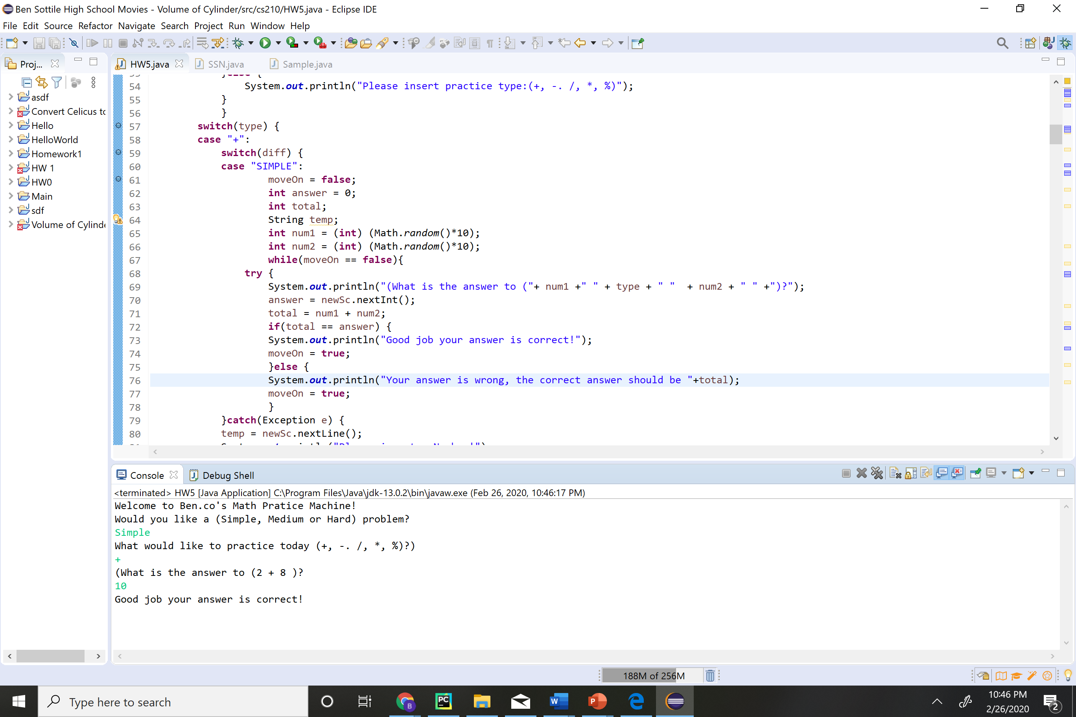

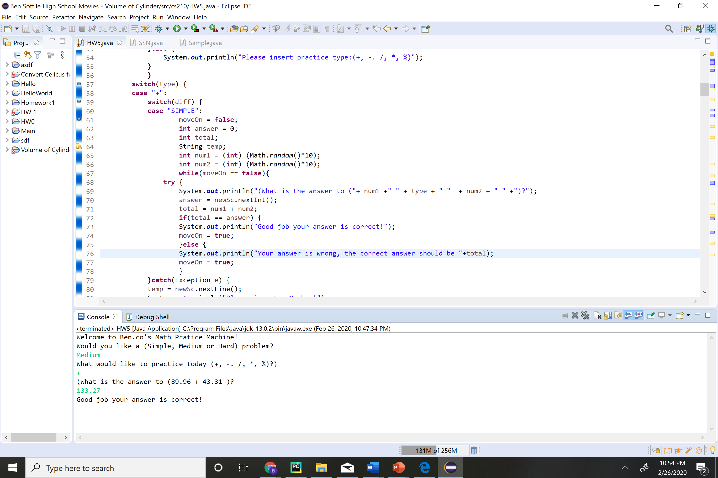

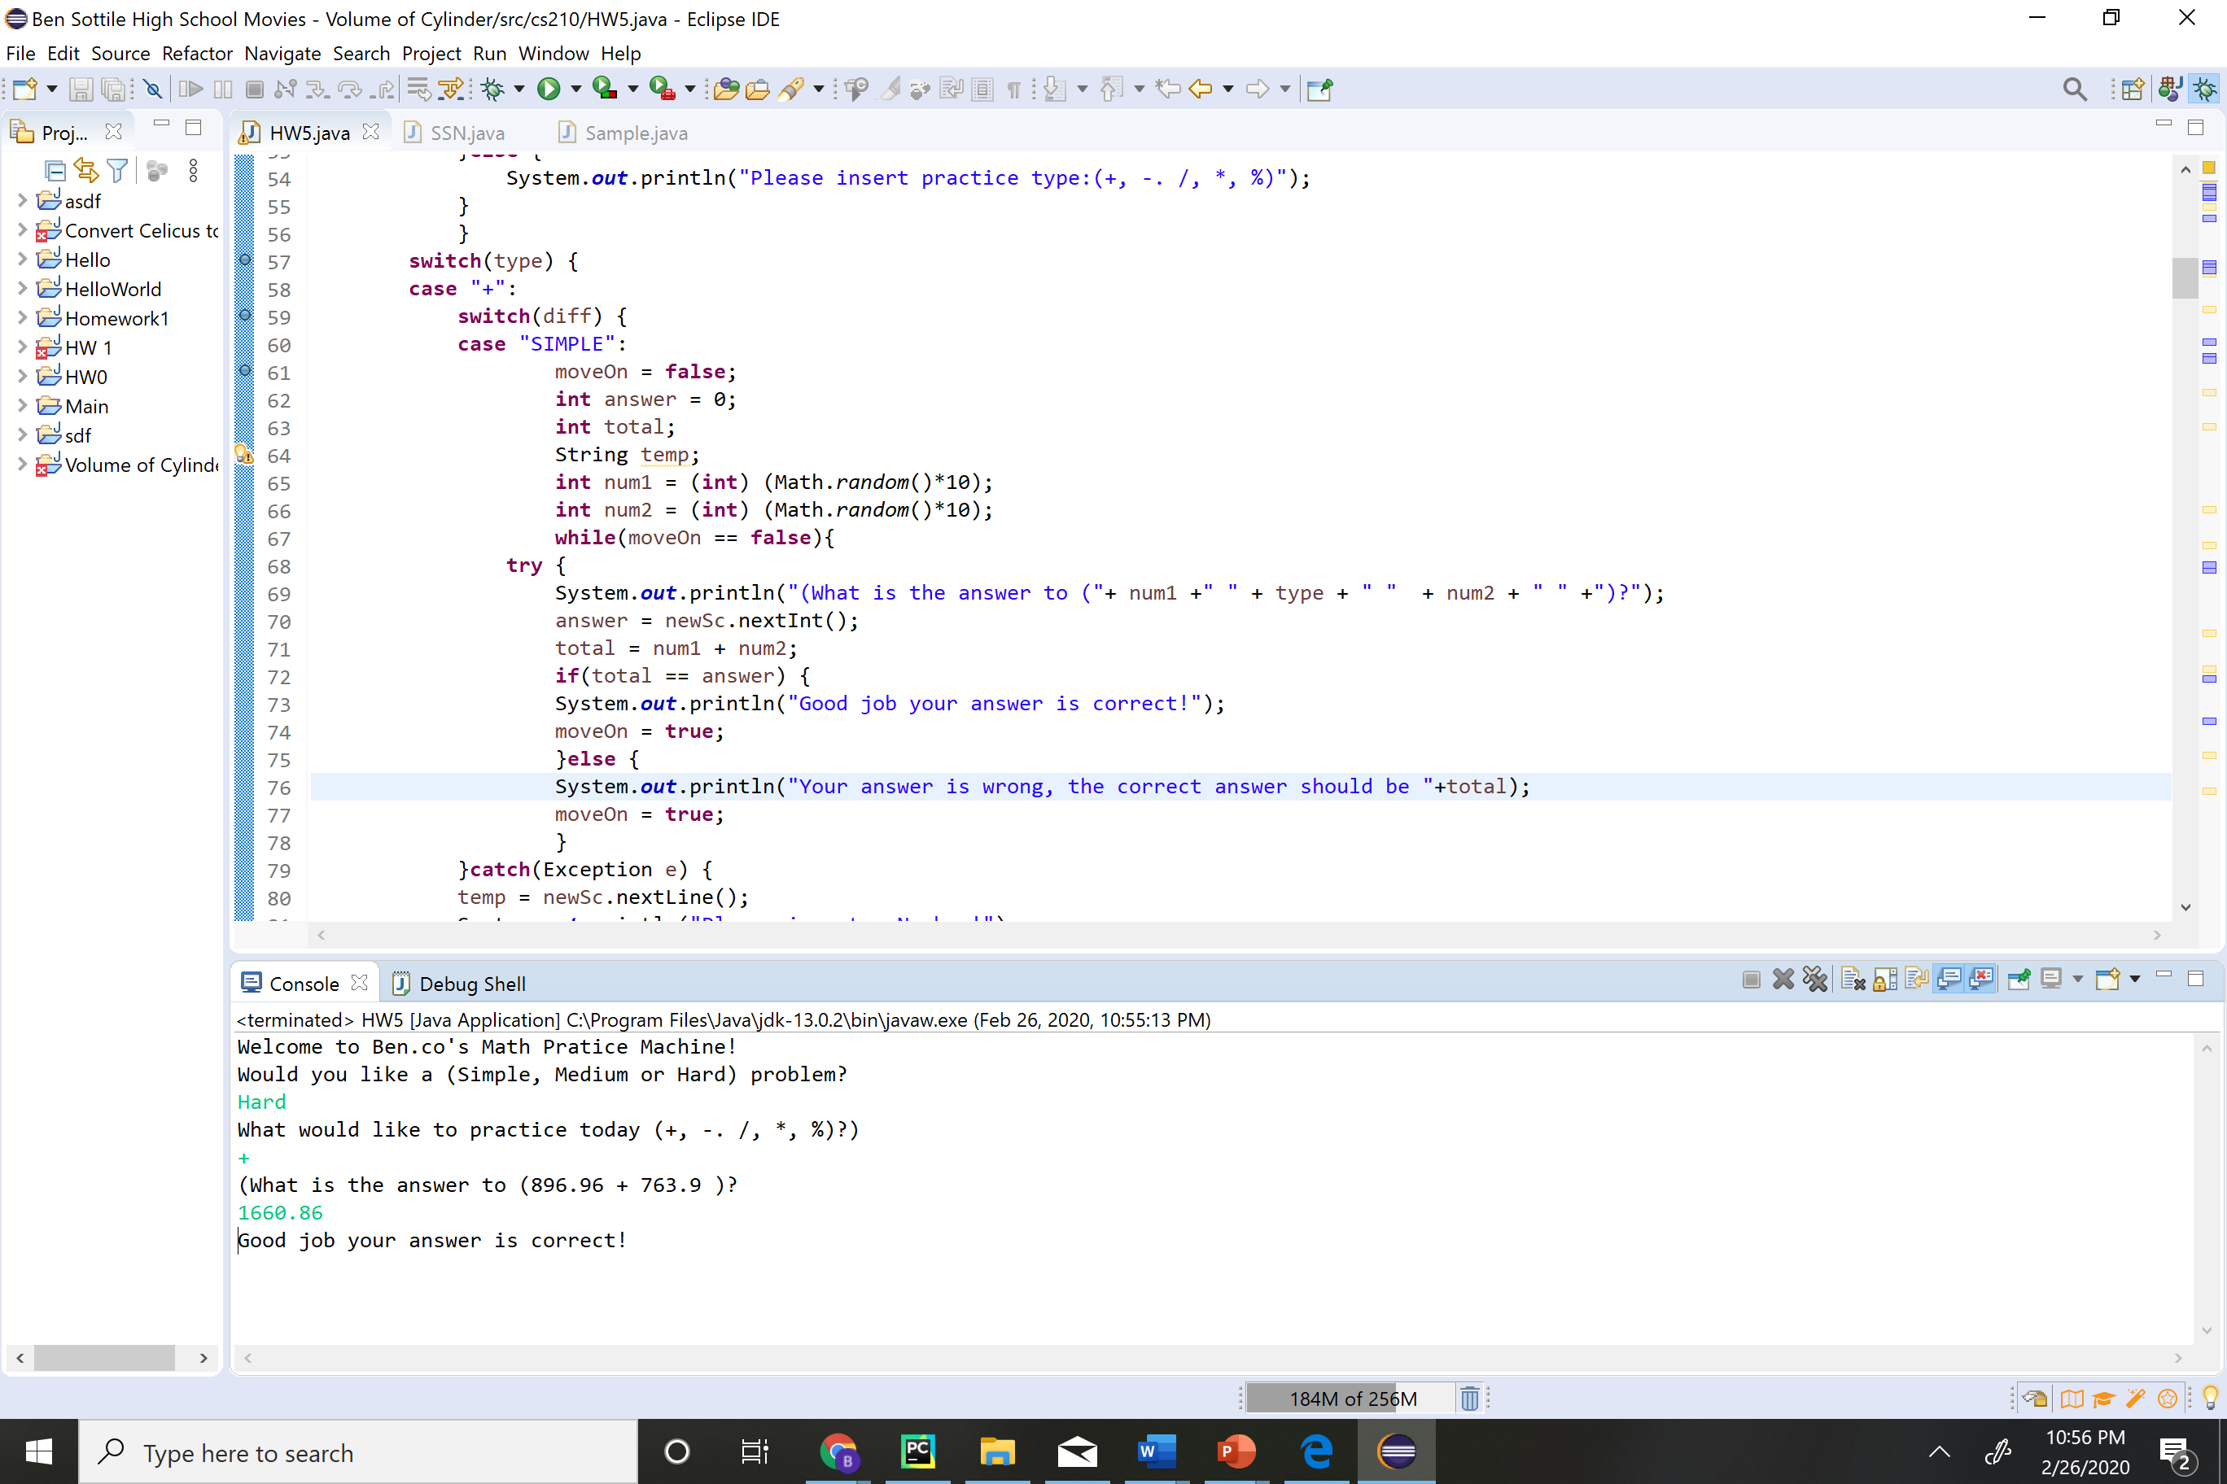

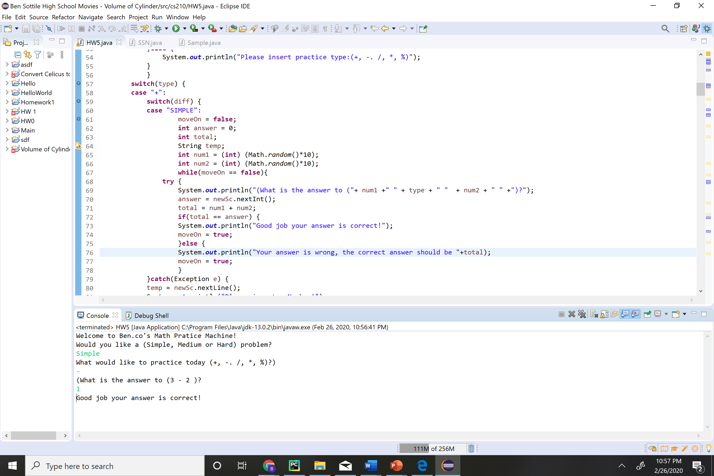

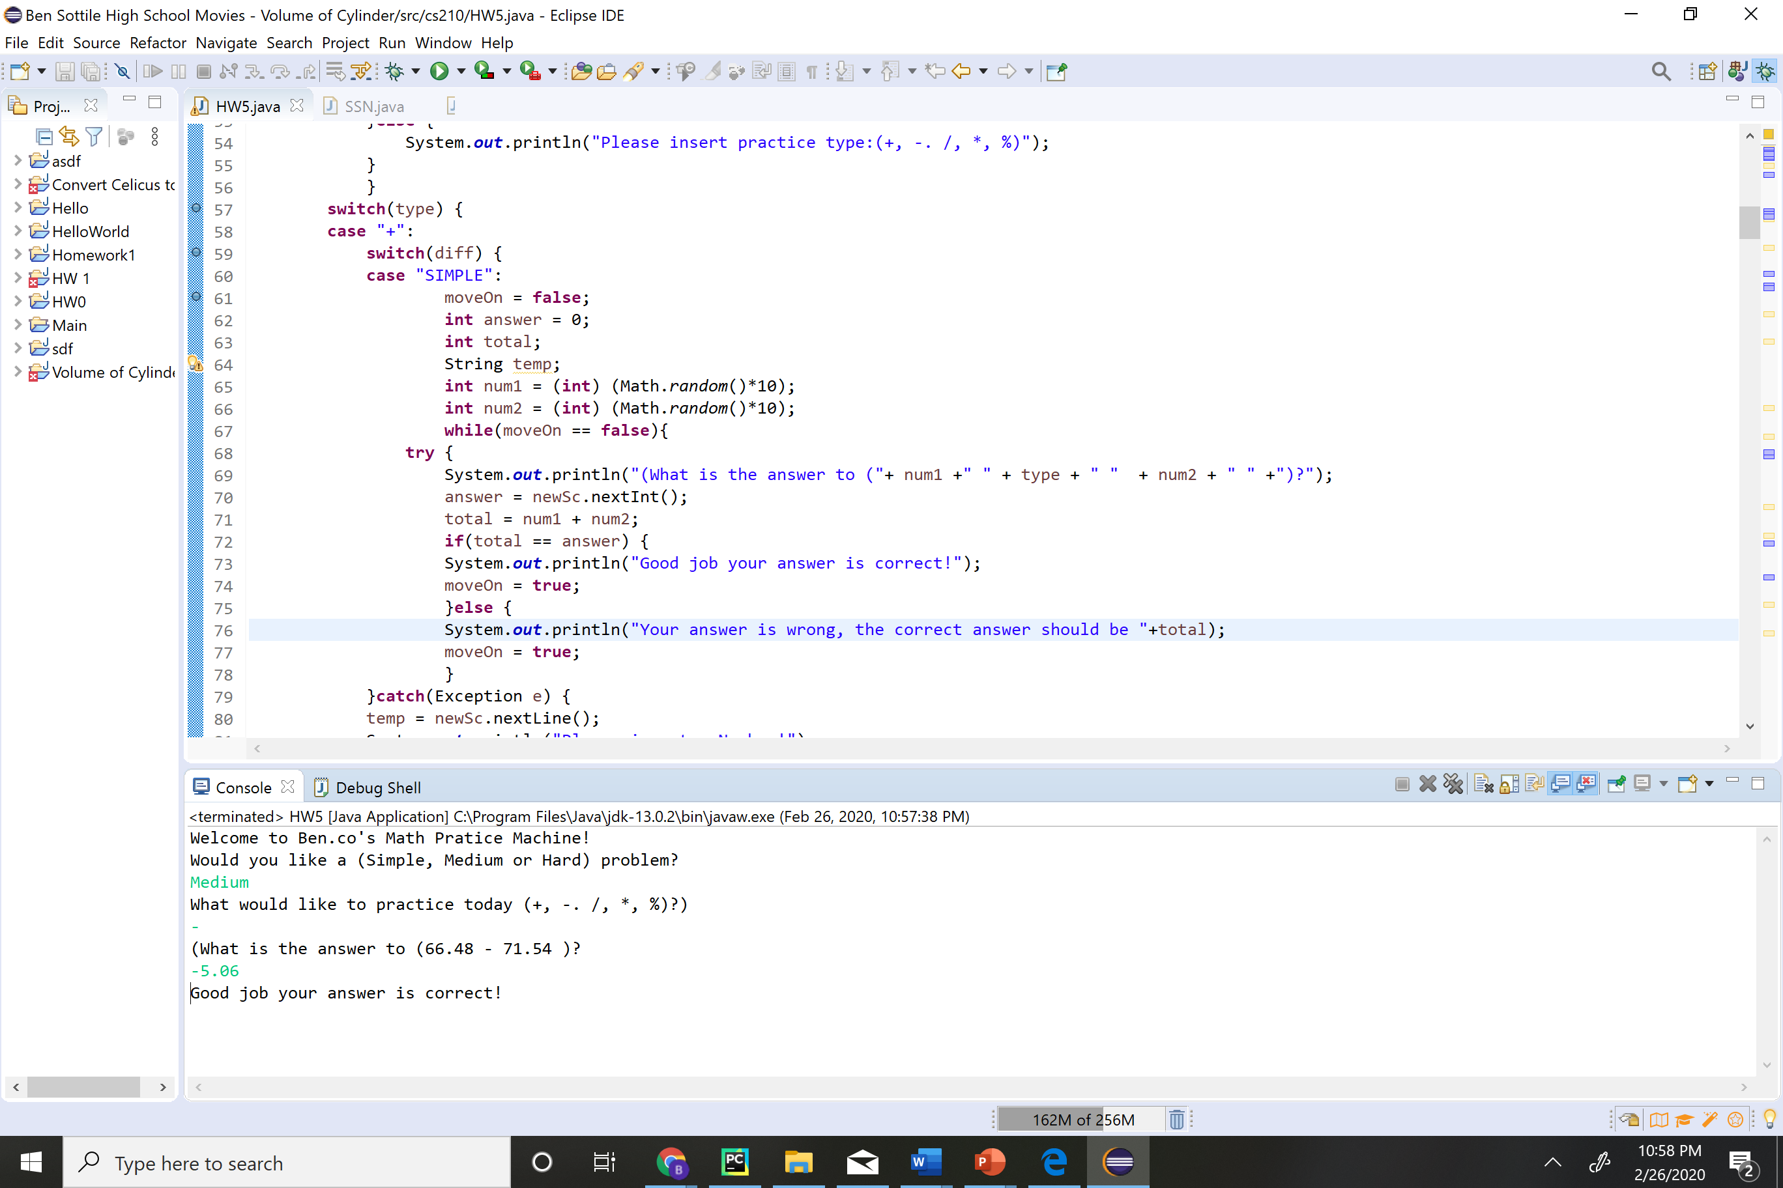

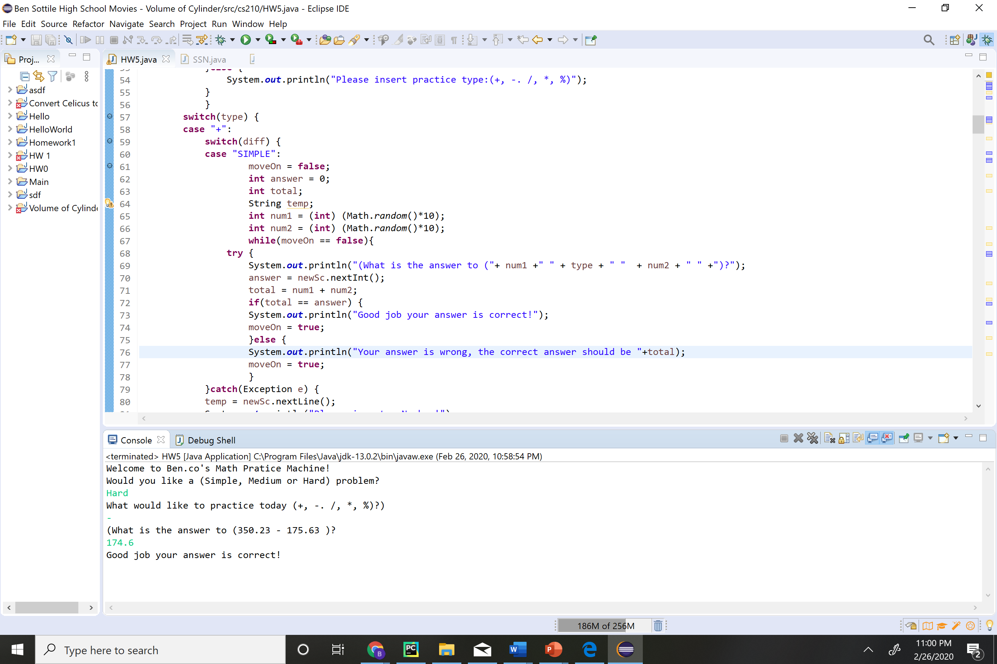

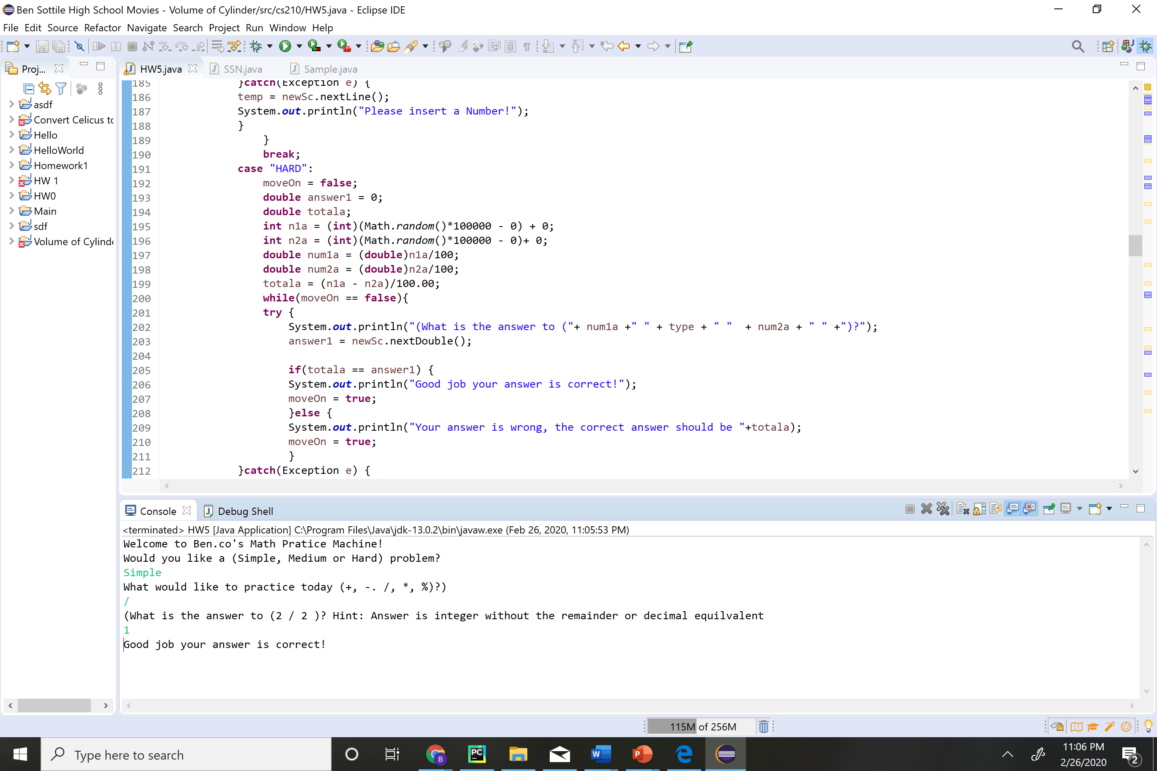

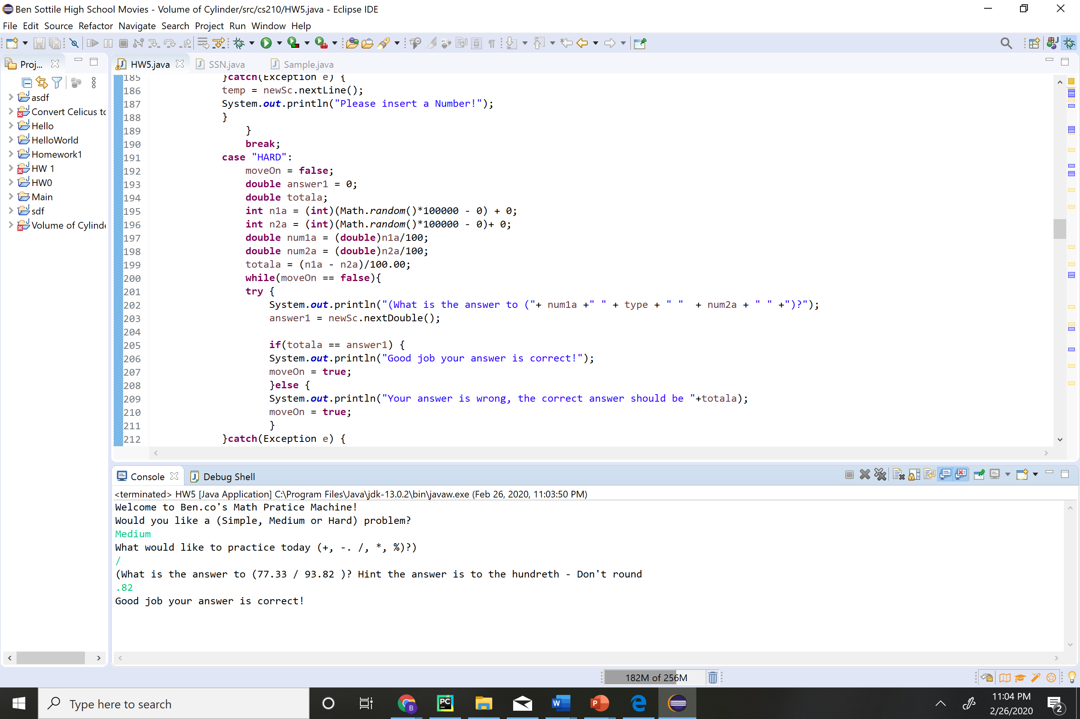

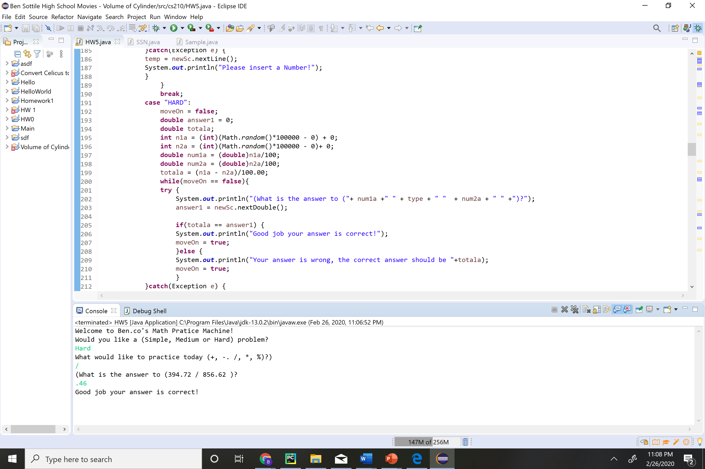

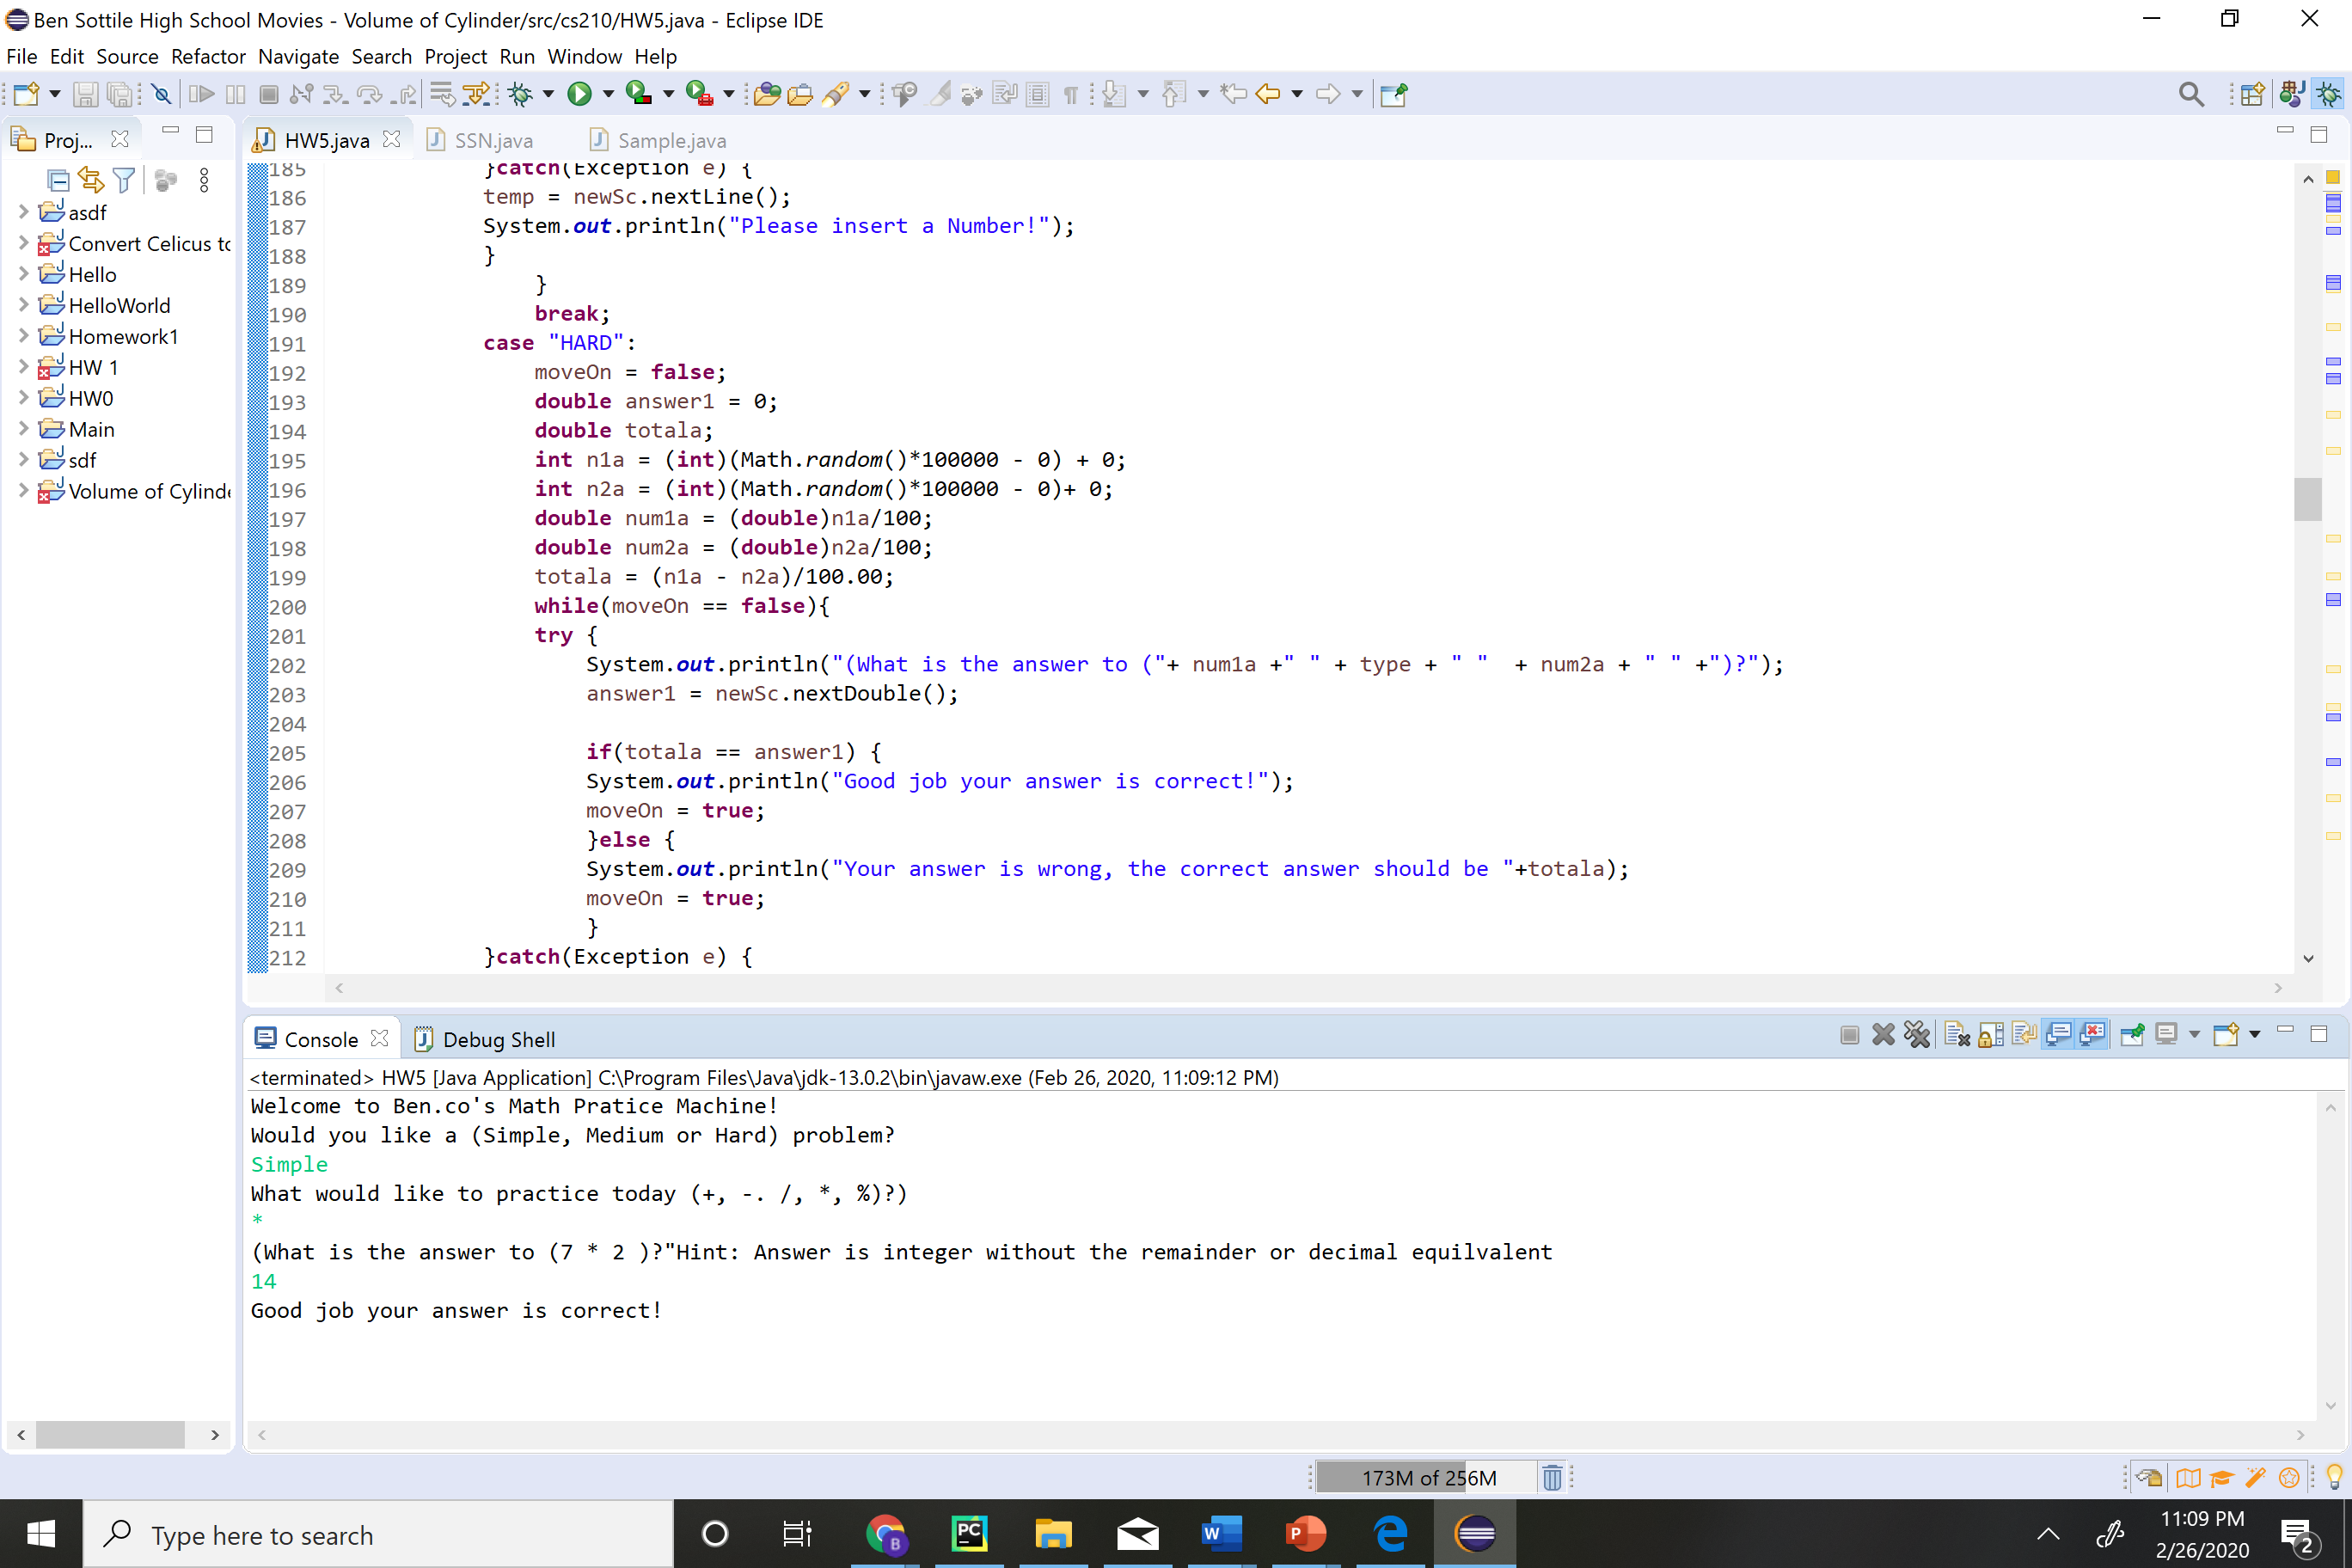

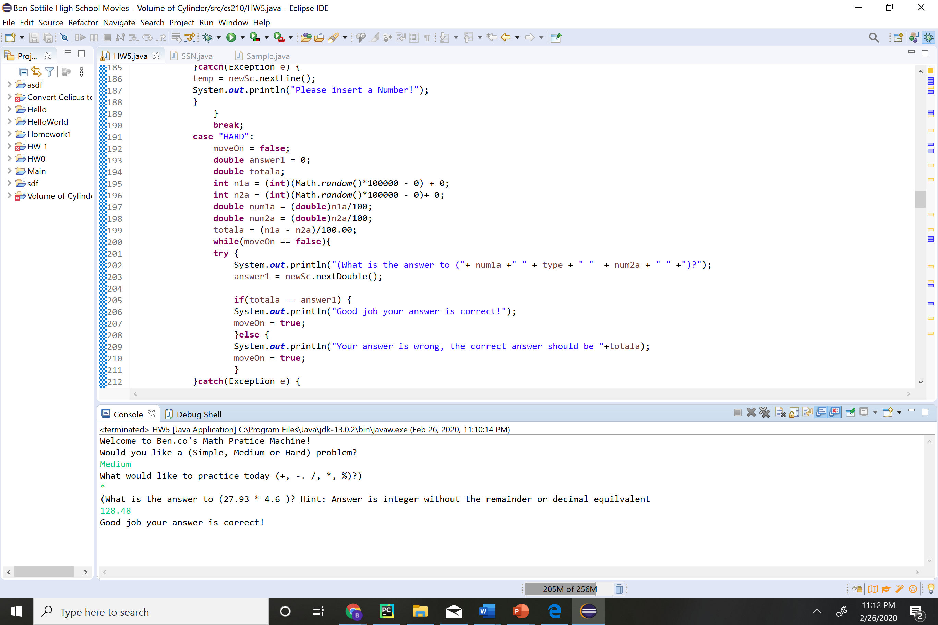

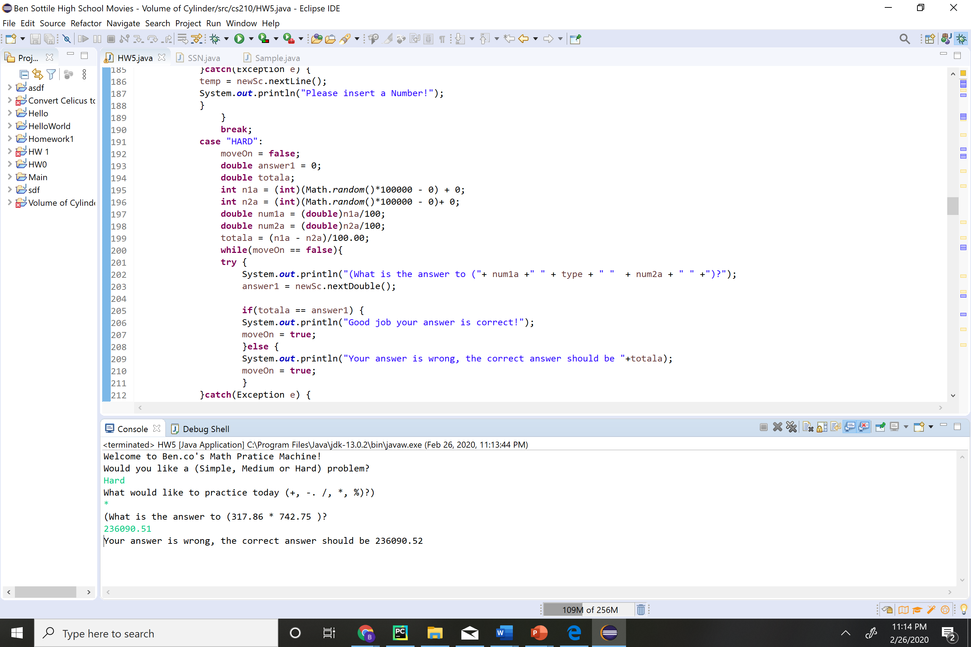

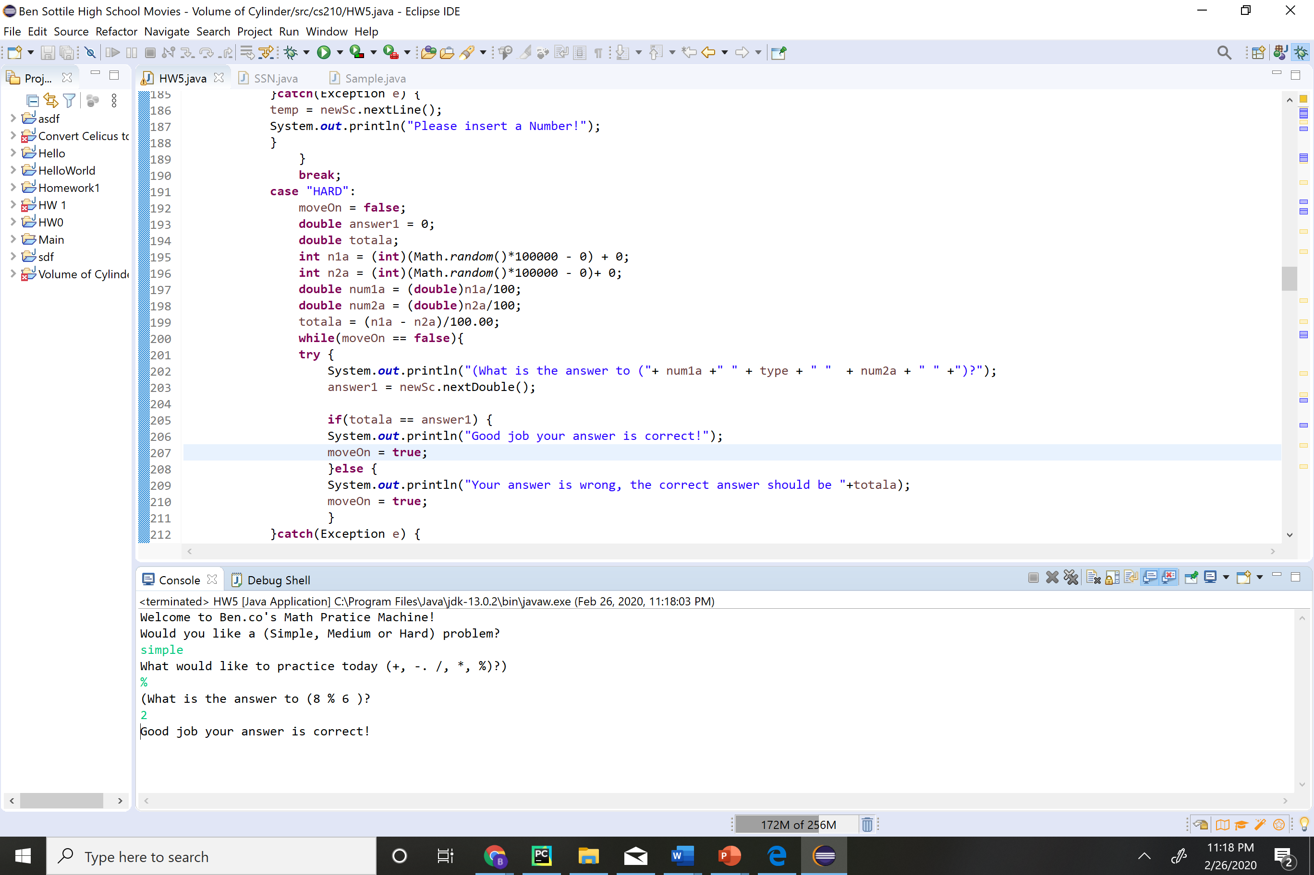

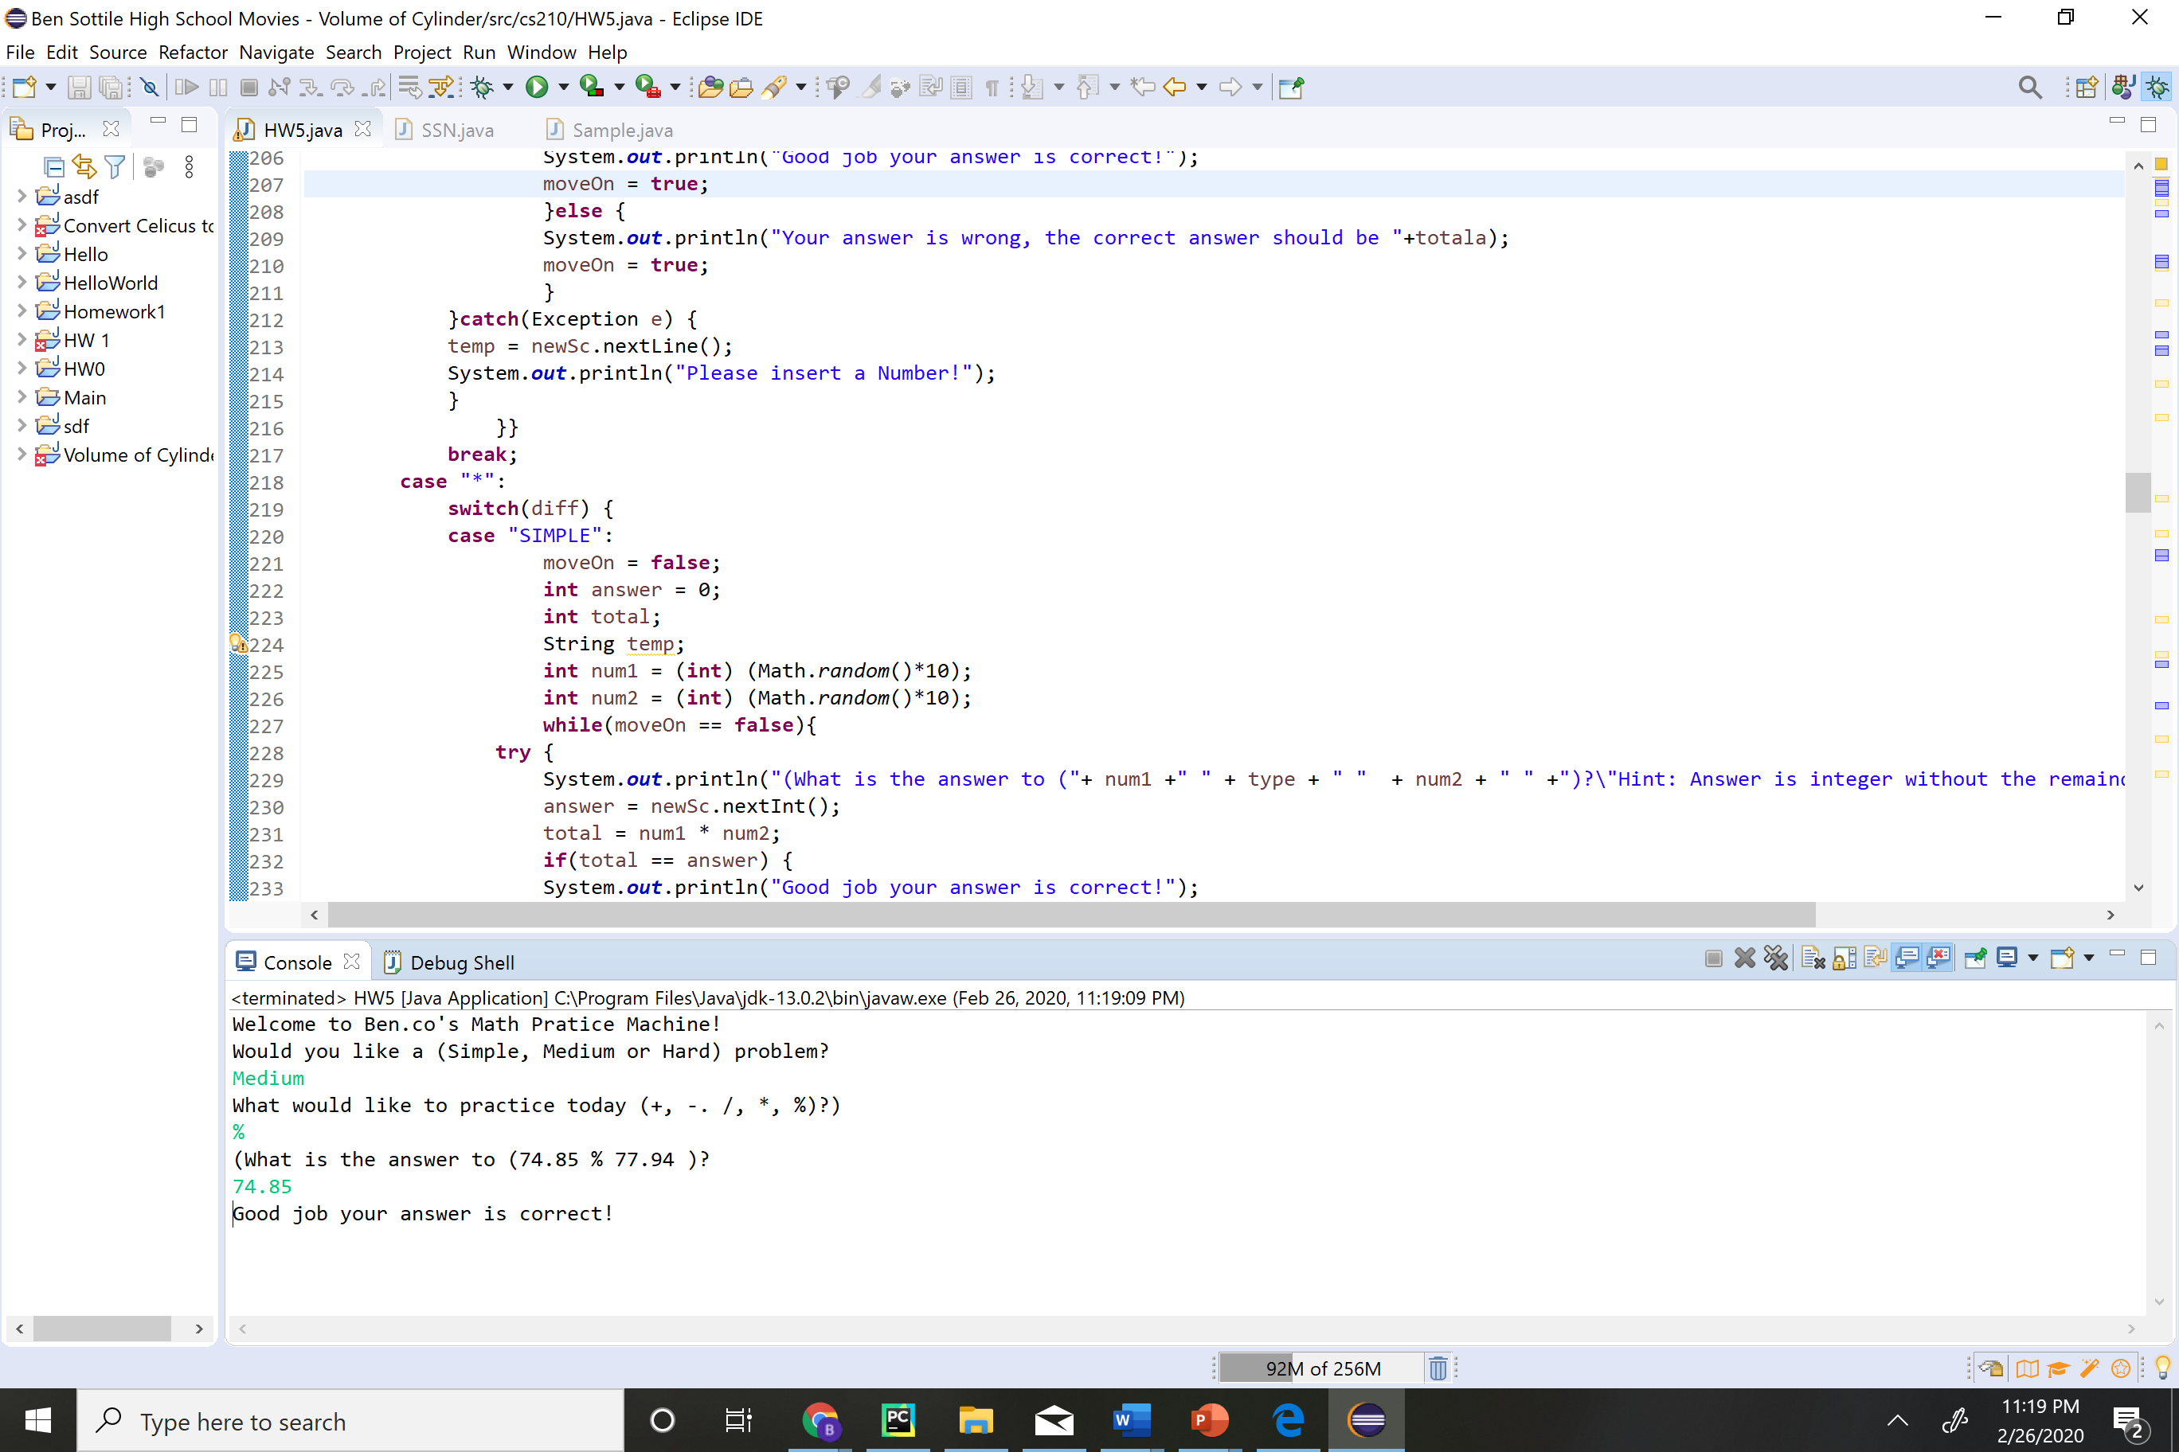

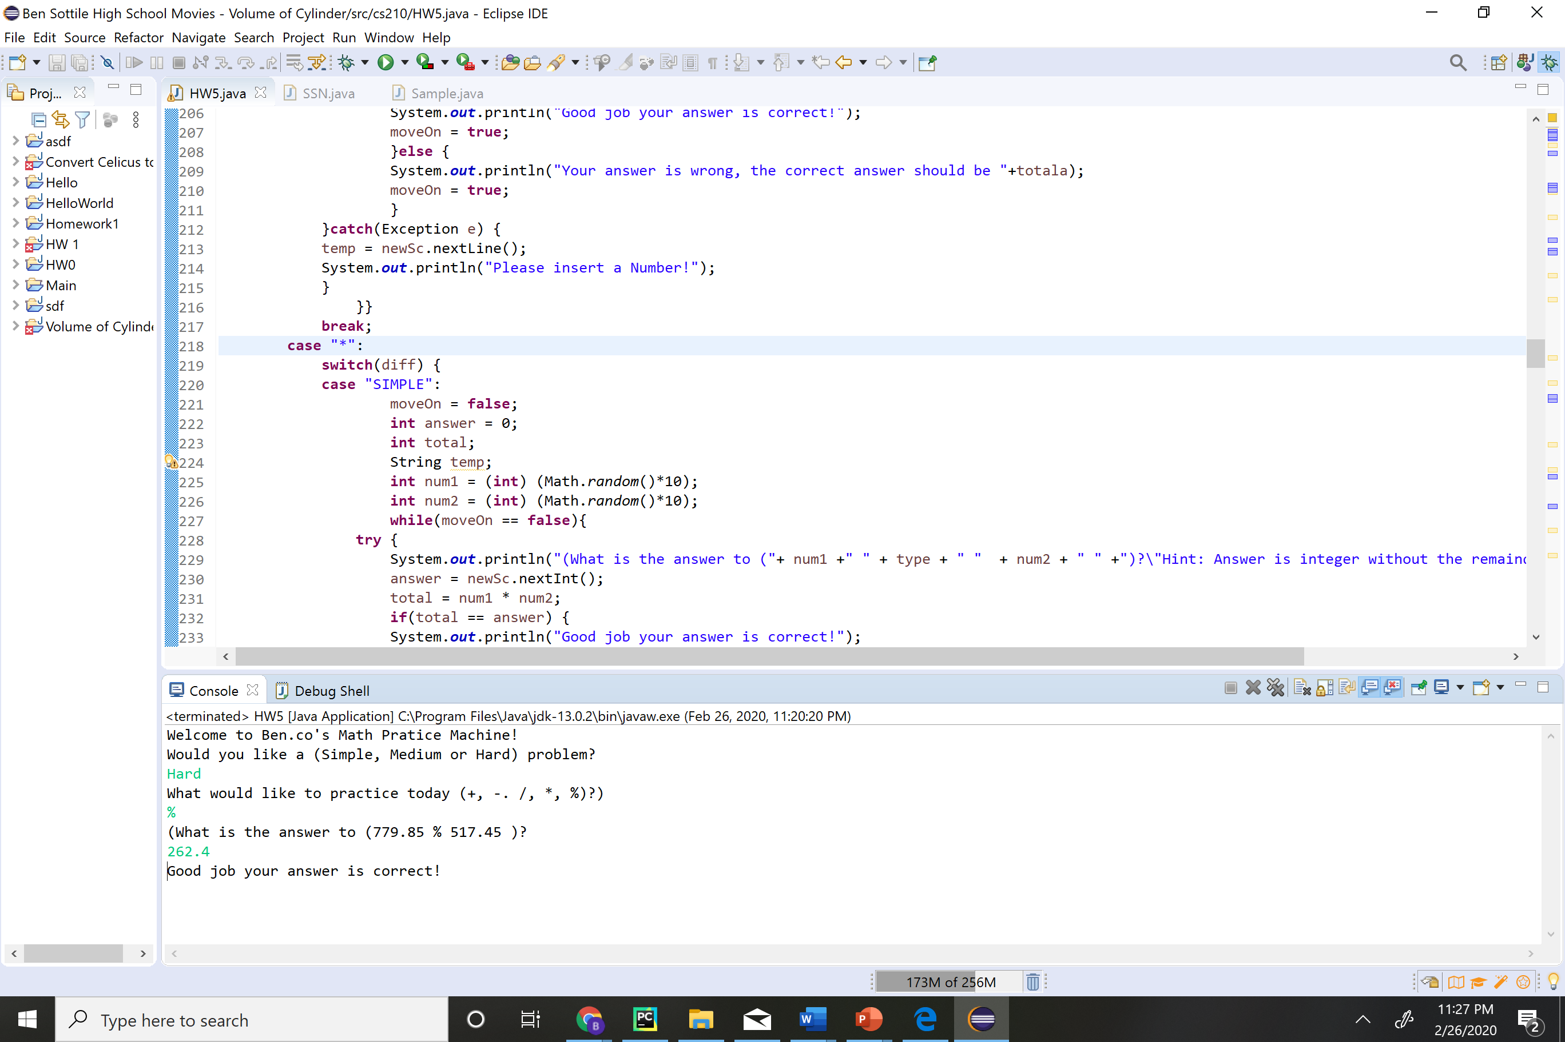

Extra point: Show a test case with results that throws and exception and you handled it in your code. (2 pt)

